**Best Practices of Unit Tests**

**Isolated / Stand-alone**

(separated from any other dependencies such as file system or database)

**Test single method at-a-time**

(should not test more than one method in a single test case)

**Unordered**

(can be executed in any order)

**Fast**

(Tests should take little time to run (about few milliseconds))

**Repeatable**

(Tests can run repeatedly but should give same result, if no changes in the actual source code)

**Timely**

(Time taken for writing a test case should not take longer time, than then time taken for writing the code that is being tested)

**Mocking the DbContext**

**Test Double**

A "test double" is an object that look and behave like their production equivalent objects.

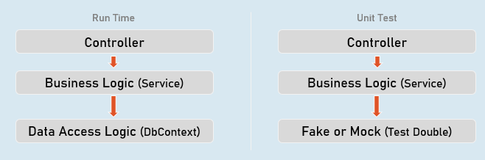

A "test double" is an object that look and behave like their production equivalent objects.

**Fake**

An object that providers an alternative (dummy) implementation of an interface

**Mock**

An object on which you fix specific return value for each individual method or property, without actual / full implementation of it.

**Mocking the DbContext**

Install-Package Moq

Install-Package EntityFrameworkCoreMock.Moq

**Mocking the DbContext:**

var dbContextOptions = new DbContextOptionsBuilder<DbContextClassName>().Options;

//mock the DbContext

DbContextMock<DbContextClass> dbContextMock = new DbContextMock<DbContextClass>(dbContextOptions);

var initialData = new List<ModelClass>() { … };

//mock the DbSet

var dbSetMock = dbContextMock.CreateDbSetMock(temp => temp.DbSetName, initialData);

//create service instance with mocked DbContext

var service = newServiceClass(dbContextMock.Object);

**AutoFixture**

AutoFixture generates objects of the specified classes and their properties with some fake values based their data types.

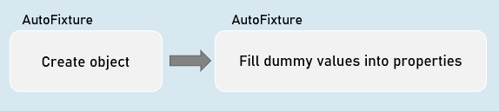

**Normal object creation**

new ModelClass() {

Property1 = value,

Property2 = value

}

**With AutoFixture**

Fixture.Create<ModelClass>(); //initializes all properties of the specified model class with dummy values

**AutoFixture**

Install-Package AutoFixture

**Working with AutoFixture:**

var fixture = new Fixture();

//Simple AutoFixture

var obj1 = fixture.Create<ModelClass>();

//Customization with AutoFixture

var obj2 = fixture.Build<ModelClass>()

.With(temp => temp.Property1, value)

.With(temp => temp.Property2, value)

.Create();

**Fluent Assertions**

Fluent Assertions are a set of extension methods to make the assertions in unit testing more readable and human-friendly.

Install-Package FluentAssertions

**Assert**

//Equal

Assert.Equal(expected, actual);

//Not Equal

Assert.NotEqual(expected, actual);

//Null

Assert.Null(actual);

//Not Null

Assert.NotNull(actual);

//True

Assert.True(actual);

//False

Assert.False(actual);

//Empty

Assert.Empty(actual);

//Not Empty

Assert.NotEmpty(actual);

//Null or empty

Assert.True(string.IsNullOrEmpty(actual)); //string

Assert.True(actual == null || actual.Length == 0); //collection

//Should not be null or empty

Assert.False (string.IsNullOrEmpty(actual)); //string

Assert.False(actual == null || actual.Length == 0); //collection

//number should be positive

Assert.True(actual > 0);

//number should be negative

Assert.True(actual < 0);

//number should be >= expected

Assert.True(actual >= expected);

//number should be <= expected

Assert.True(actual <= expected);

//number should be in given range

Assert.True(actual >= minimum && actual <= maximum);

//number should not be in given range

Assert.True(actual < minimum || actual > maximum);

//check data type

Assert.IsType<ExpectedType>(actual);

//Compare properties of two objects (Equals method SHOULD BE overridden)

Assert.Equal(expected, actual);

//Compare properties (should not be equal) of two objects (Equals method SHOULD BE overridden)

Assert.NotEqual(expected, actual);

**Fluent Assertion**

//Equal

actual.Should().Be(expected);

//Not Equal

actual.Should().NotBe(expected);

//Null

actual.Should().BeNull();

//Not Null

actual.Should().NotBeNull();

//True

actual.Should().BeTrue();

//False

actual.Should().BeFalse();

//Empty

actual.Should().BeEmpty();

//Not Empty

actual.Should().NotBeEmpty();

//Null or empty

actual.Should().BeNullOrEmpty();

//Should not be null or empty

actual.Should().NotBeNullOrEmpty();

//number should be positive

actual.Should().BePositive();

//number should be negative

actual.Should().BeNegative();

//number should be >= expected

actual.Should().BeGreaterThanOrEqualTo(expected);

//number should be <= expected

actual.Should().BeLessThanOrEqualTo(expected);

//number should be in given range

actual.Should().BeInRange(minimum, maximum);

//number should not be in given range

actual.Should().NotBeInRange(minimum, maximum);

//number should be in given range

actual.Should().BeInRange(minimum, maximum);

//number should not be in given range

actual.Should().NotBeInRange(minimum, maximum);

//check data type (same type)

actual.Should().BeOfType<ExpectedType>();

//check data type (same type or derived type)

actual.Should().BeAssignableTo<ExpectedType>();

//Compare properties of two objects (Equals method NEED NOT be overridden)

actual.Should().BeEquivalentTo(expected);

//Compare properties (should not equal) of two objects (Equals method NEED NOT be overridden)

actual.Should().BeNotEquivalentTo(expected);

**Fluent Assertions - Collections:**

actualCollection.Should().BeEmpty();

actualCollection.Should().NotBeEmpty();

actualCollection.Should().HaveCount(expectedCount);

actualCollection.Should().NotHaveCount(expectedCount);

actualCollection.Should().HaveCountGreaterThanOrEqualTo(expectedCount);

actualCollection.Should().HaveCountLessThanOrEqualTo(expectedCount);

actualCollection.Should().HaveSameCount(expectedCollection);

actualCollection.Should().NotHaveSameCount(expectedCollection);

actualCollection.Should().BeEquivalentTo(expectedCollection);

actualCollection.Should().NotBeEquivalentTo(expectedCollection);

actualCollection.Should().ContainInOrder(expectedCollection);

actualCollection.Should().NotContainInOrder(expectedCollection);

actualCollection.Should().OnlyHaveUniqueItems(expectedCount);

actualCollection.Should().OnlyContain(temp => condition);

actualCollection.Should().BeInAscendingOrder(temp => temp.Property);

actualCollection.Should().BeInDescendingOrder(temp => temp.Property);

actualCollection.Should().NotBeInAscendingOrder(temp => temp.Property);

actualCollection.Should().NotBeInDescendingOrder(temp => temp.Property);

delegateObj.Should().Throw<ExceptionType>();

delegateObj.Should().NotThrow<ExceptionType>();

await delegateObj.Should().ThrowAsync<ExceptionType>();

await delegateObj.Should().NotThrowAsync<ExceptionType>();

**Repository**

Repository (or Repository Pattern) is an abstraction between Data Access Layer (EF DbContext) and business logic layer (Service) of the application.

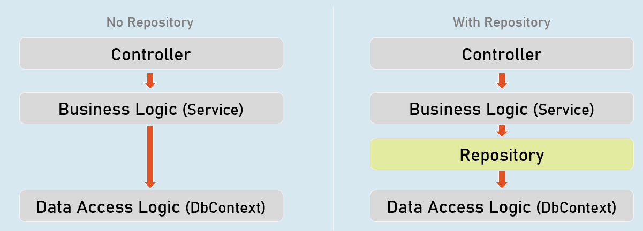

**Unit Testing**

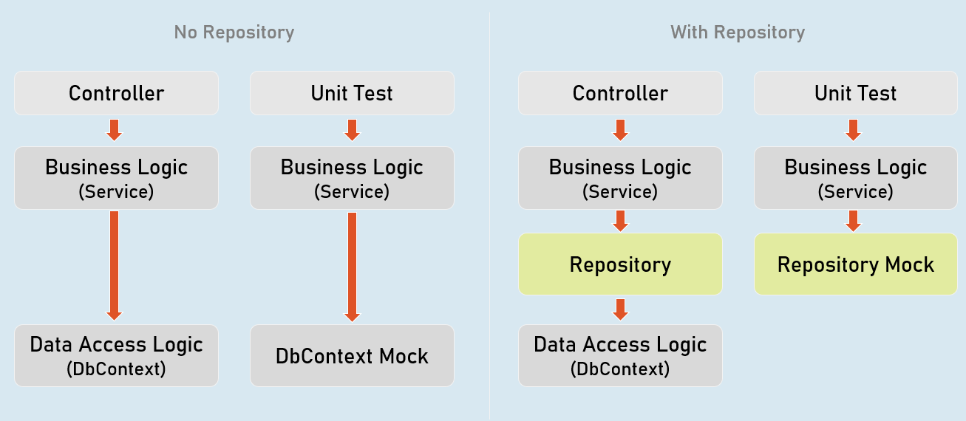

**Benefits of Repository Pattern**

**Loosely-coupled business logic (service) & data access.**

(You can independently develop them).

**Changing data store**

(You can create alternative repository implementation for another data store, when needed).

**Unit Testing**

(Mocking the repository is much easier (and preferred) than mocking DbContext).

**Mocking the Repository**

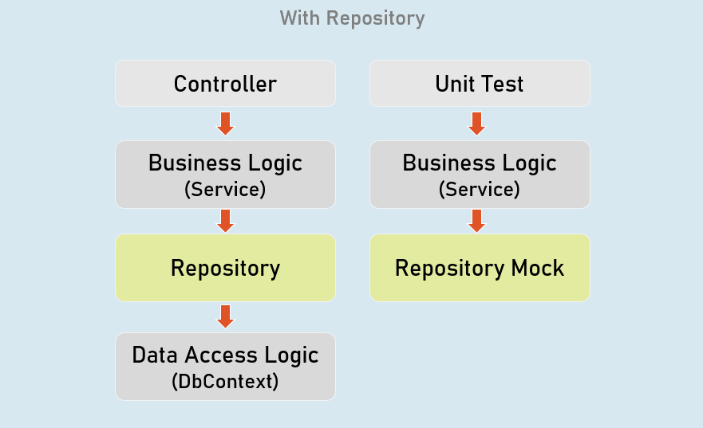

Install-Package Moq

**Mocking the Repository:**

//mock the repository

Mock<IRepository> repositoryMock = new Mock<IRepository>();

//mock a method repository method

repositoryMock.Setup(temp => temp.MethodName(It.Any<ParameterType>()))

.Returns(return_value);

//create service instance with mocked repository

var service = newServiceClass(repositoryMock.Object);

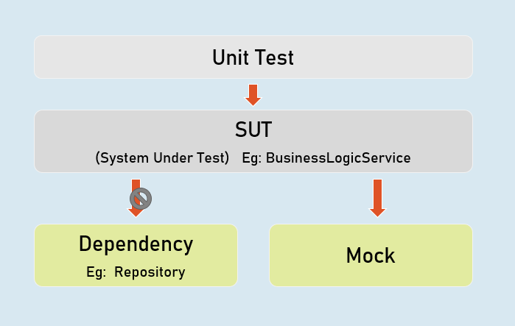

**Mock<IPersonsRepository>**

Used to mock the methods of IPersonsRepository.

**IPersonsRepository**

Represents the mocked object that was created by Mock<T>.

**Unit Testing the Controller**

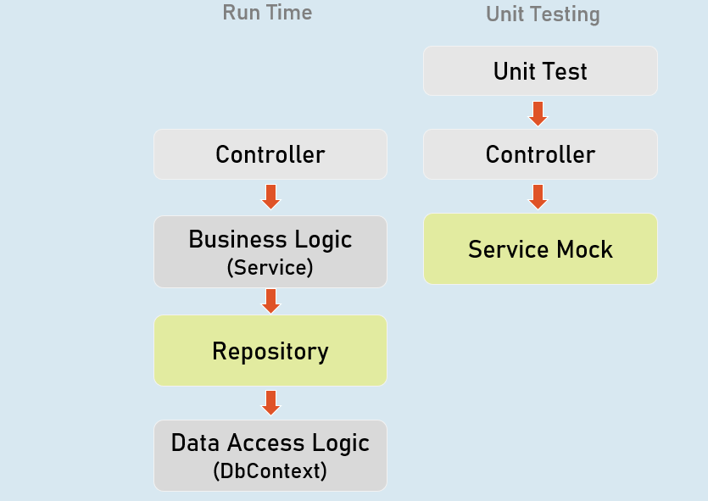

**Unit Testing the Controller:**

//Arrange

ControllerName controller = new ControllerName();

//Act

IActionResult result = controller.ActionMethod();

//Assert

result.Should().BeAssignableTo<ActionResultType>(); //checking type of action result

result.ViewData.Model.Should().BeAssignableTo<ExpectedType>(); //checking type of model

result.ViewData.Model.Should().Be(expectedValue); //you can also use any other assertion

**EFCore In-Memory Provider**

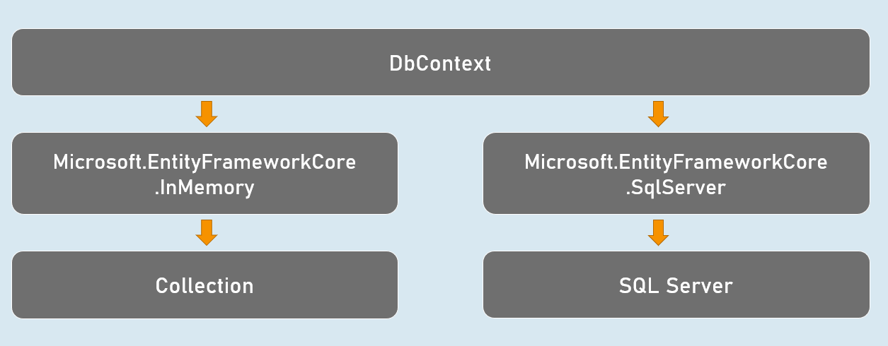

Install-Package Microsoft.EntityFrameworkCore.InMemory

**Using In-memory provider:**

var dbContextOptions =

new DbContextOptionsBuilder<DbContextClassName>()

.UseInMemoryDatabase("database_name");

.Options;

var dbContext = newDbContextClassName(dbContextOptions);

**Integration Test**

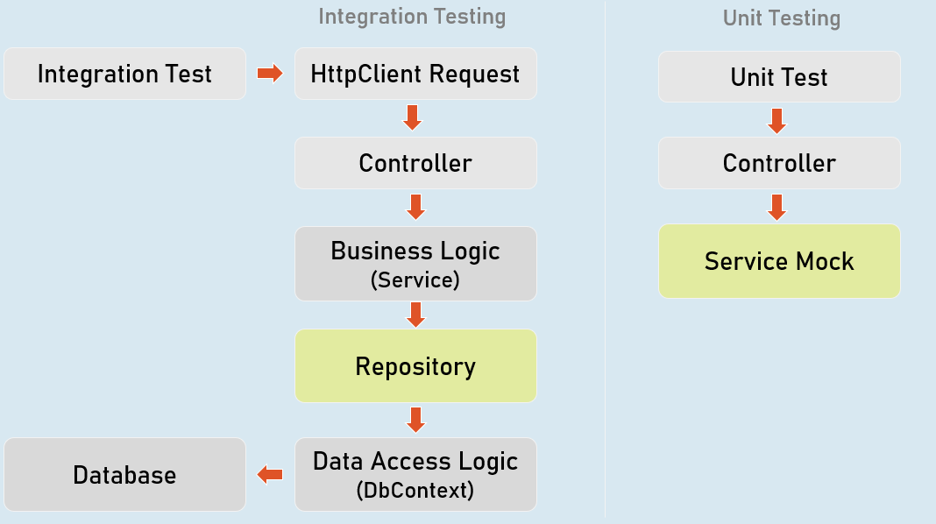

//Create factory

WebApplicationFactory factory = new WebApplicationFactory();

//Create client

HttpClient client = factory.CreateClient();

//Send request client

HttpResponseMessage response = await client.GetAsync("url");

//Assert

result.Should().BeSuccessful(); //Response status code should be 200 to 299